DOCAYA
Enterprise Electronic Document Management System
Azure SQL Deployment Guide
Version 1.3
Provisioning · Identity · Script execution · Validation · Operations · Rollback

Attribute | Value
Document type | Azure SQL Deployment Guide — step-by-step installation runbook
Version | 1.3 — accompanies the Docaya Database Deployment Scripts v1.3
Target platform | Azure SQL Database (compatible with SQL Server 2019 and later)
Companion artefacts | 16 ordered T-SQL scripts (00–15) · Docaya-Database-Design-Document-v1.3.docx
Authoritative source | Docaya Technical Architecture Document v1.3, Sections 11, 14.6.3 and 18
Intended reader | Cloud infrastructure engineer, database engineer, release engineer
Status | Draft for Review
Classification | OFFICIAL – Internal
Date | 13 September 2026

How to use this guide Work through Sections 3 to 8 in order. Each section ends with a verification step that must pass before the next begins. Section 9 covers what to do when something fails, and Section 10 lists the two items that must be closed before the database is trusted in production.

1. Overview

1.1 What This Deployment Creates
A single Azure SQL Database containing ten bounded schemas, 63 tables, nine reporting views, seven stored procedures, four functions and a least-privilege role model with seven database roles — one per Docaya workload identity.
Object type | Count | Notes
Schemas | 10 | stg · docaya · wf · sec · ref · idx · ntf · aud · ops · rpt (plus rls for the security predicate)
Tables | 63 | Distributed across nine data schemas; rpt contains views only
Foreign keys | 92 | All resolve forward in the deployment order; none cascade into a business schema
Check constraints | 68 | Including the 16 architectural guarantees enforced in the database
Indexes | 58 | 28 filtered, 14 covering, 9 unique-filtered expressing business rules
Views | 9 | All in rpt; the Power BI semantic model reads nothing else
Procedures / functions | 7 / 4 | Serialisation, atomicity and working-day arithmetic
Triggers | 1 | aud.TR_AuditEvent_Immutable (append-only enforcement)
Database roles | 7 | One per workload identity
GRANT / DENY | 63 / 29 | Least privilege with explicit isolation

1.2 Deployment Topology

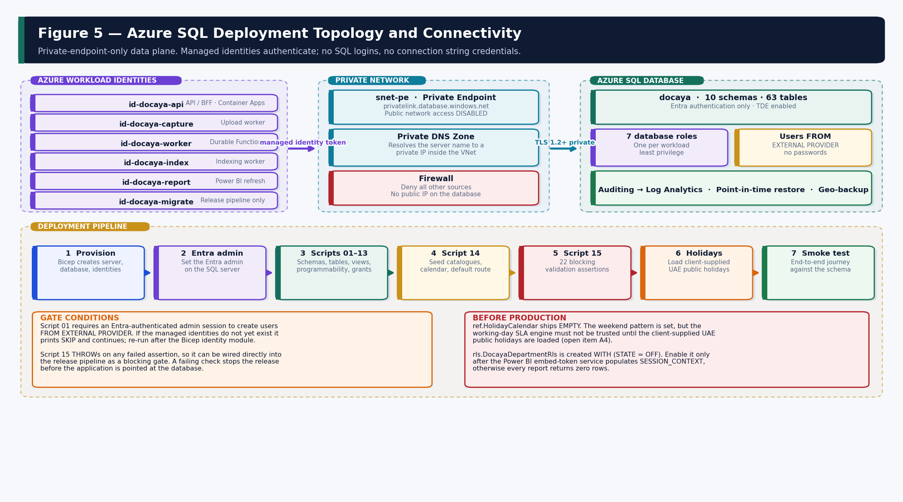
Figure 1 — Workload identities, private connectivity, the database, and the seven-stage deployment pipeline.

1.3 Deployment Principles
- Managed identity only. No SQL logins, no passwords, no connection string carrying credentials. Every workload authenticates with its own Azure managed identity.
- Private endpoint only. Public network access on the database is disabled. The application reaches SQL over a private endpoint with private DNS resolution.
- Idempotent scripts. Every script may be re-run safely. A failed deployment is corrected and re-executed from the failing file, not unwound.
- Order is mandatory. Foreign keys resolve forward: ref before sec, sec before docaya, docaya before everything that references a document.
- Validation is a gate. Script 15 runs 22 assertions and THROWs on failure, so it wires directly into the release pipeline as a blocking step.
- DDL is pipeline-only. The migration identity holds ALTER rights and is never used at runtime. It has no data-plane SELECT on document content.

2. Prerequisites

2.1 Azure Resources
Resource | Requirement | Created by
Azure SQL logical server | In an approved UAE region. Public network access disabled; minimum TLS 1.2. | infra/modules/sql.bicep
Azure SQL database | Service tier per environment (see 2.3). Transparent Data Encryption enabled. | infra/modules/sql.bicep
Private endpoint | In snet-pe, with a private DNS zone for privatelink.database.windows.net. | infra/modules/network.bicep
Managed identities | Seven user-assigned identities, one per workload. | infra/modules/identity.bicep
Log Analytics workspace | Target for Azure SQL auditing and diagnostic settings. | infra/modules/observability.bicep
Key Vault | Holds any residual third-party secret. No database credential is stored anywhere. | infra/modules/keyvault.bicep

2.2 Identities Required
The seven managed identities must exist before script 01 runs. Names must match exactly — script 01 creates database users FROM EXTERNAL PROVIDER using these display names.
Managed identity | Database role | Workload
id-docaya-api | docaya_api_role | ASP.NET Core API and backend-for-frontend
id-docaya-capture | docaya_capture_role | Upload and staging worker
id-docaya-worker | docaya_worker_role | Durable Functions — review orchestration, SLA sweep, promotion
id-docaya-index | docaya_index_role | Indexing worker — builds the Document Index Record
id-docaya-report | docaya_report_role | Power BI semantic-model refresh
id-docaya-support | docaya_support_role | Operational support — technical status only
id-docaya-migrate | docaya_migrate_role | Release pipeline — DDL only, never at runtime

If the identity names differ Edit the @identities table at the top of 01_schemas_and_principals.sql to match the names your Bicep identity module actually created. The role names themselves should not be changed — the grant script and the validation checks reference them.

2.3 Service Tier Guidance
Environment | Suggested tier | Rationale
dev | General Purpose · Serverless, 1–4 vCore, auto-pause | Low cost; auto-pause is acceptable because latency on first connection does not matter.
test / UAT | General Purpose · Provisioned, 4–8 vCore, zone-redundant | Production-like behaviour so performance testing is meaningful.
production | Business Critical or General Purpose zone-redundant, sized by load test | Final sizing is confirmed by performance testing, not assumed in advance.

Storage growth is driven by sec.AccessDecisionLog, aud.AuditEvent and ntf.Notification. Section 8.3 covers the growth profile and the pruning options for each.

2.4 Tooling
Tool | Purpose | Minimum
Azure CLI | Provisioning, setting the Entra admin, firewall operations | 2.50+
sqlcmd (go-sqlcmd or ODBC 18) | Script execution with Entra authentication | ODBC Driver 18 / go-sqlcmd 1.4+
Azure Data Studio or SSMS | Interactive inspection and troubleshooting | Optional but recommended
PowerShell + SqlServer module | Alternative execution path with Invoke-Sqlcmd | Az 10+ · SqlServer 22+

3. Stage 1 — Provision the Database
Provisioning is performed by the Bicep infrastructure package. This section records what that package must produce so the database is in the correct state before any script runs.

3.1 Required Server and Database Settings
Setting | Required value | Why
Public network access | Disabled | The data plane is reached only through the private endpoint.
Minimum TLS version | 1.2 | Enforced in transit encryption.
Entra-only authentication | Enabled (recommended) | Removes SQL authentication entirely; managed identity becomes the only path.
Transparent Data Encryption | Enabled | Encryption at rest. Customer-managed keys are available where client policy requires (open item A9).
Auditing | Enabled to Log Analytics | Platform-level audit, independent of and additional to the application aud schema.
Backup retention | Point-in-time 7–35 days; long-term per policy | Supports the RPO ≤ 5 min / RTO ≤ 1 hr objective.
Collation | SQL_Latin1_General_CP1_CI_AS (default) | All text columns are NVARCHAR; Arabic content is stored as Unicode.

3.2 Set the Entra Administrator
Script 01 creates database users FROM EXTERNAL PROVIDER, which requires an Entra-authenticated administrator session. Set a group as the administrator rather than an individual so the deployment does not depend on one person.
# Set an Entra group as the SQL server administrator
az sql server ad-admin create \
--resource-group rg-docaya-<env>-<region> \
--server sql-docaya-<env>-<region> \
--display-name 'Docaya SQL Administrators' \
--object-id <entra-group-object-id>

# Optional but recommended: disable SQL authentication entirely
az sql server ad-only-auth enable \
--resource-group rg-docaya-<env>-<region> \
--name sql-docaya-<env>-<region>

3.3 Verify Connectivity Before Proceeding
-- Run from a host inside the VNet (or via the deployment agent).
-- Confirms the private endpoint resolves and the session is Entra-authenticated.
SELECT
ServerName = @@SERVERNAME,
DatabaseName = DB_NAME(),
LoginName = SUSER_SNAME(),
AuthScheme = (SELECT auth_scheme FROM sys.dm_exec_connections
WHERE session_id = @@SPID),
IsEntraAdmin = IS_SRVROLEMEMBER('sysadmin');

Verification gate AuthScheme should return a value indicating Entra authentication. If it returns SQL, you are connected with a SQL login and script 01 will skip user creation. Reconnect with an Entra identity before continuing.

4. Stage 2 — Execute the Scripts

4.1 Execution Order
Order is mandatory. Every script is idempotent and may be re-run without side effects.
# | Script | Creates | Typical runtime
00 | 00_master_deploy.sql | Manifest and environment banner (no DDL) | < 1 s
01 | 01_schemas_and_principals.sql | 10 schemas · 7 roles · workload users | 2–5 s
02 | 02_ref_reference_data.sql | 14 catalogue tables | 3–6 s
03 | 03_sec_access_control.sql | 7 access-control tables + indexes | 3–6 s
04 | 04_docaya_core_registry.sql | 8 registry tables + 6 hot-path indexes | 5–10 s
05 | 05_stg_staging.sql | 6 staging tables + filtered indexes | 3–6 s
06 | 06_wf_workflow_sla.sql | 6 workflow tables + queue indexes | 4–8 s
07 | 07_idx_index_projection.sql | 5 projection tables | 3–5 s
08 | 08_ntf_notification.sql | 6 notification tables | 3–5 s
09 | 09_aud_audit.sql | 3 audit tables + immutability trigger | 2–4 s
10 | 10_ops_operational.sql | 6 operational tables | 3–5 s
11 | 11_rpt_reporting_views.sql | 9 reporting views | 2–4 s
12 | 12_programmability.sql | 4 functions · 7 procedures | 3–6 s
13 | 13_security_grants.sql | 63 GRANT · 29 DENY · RLS predicate and policy | 3–6 s
14 | 14_seed_reference_data.sql | Seed catalogues, calendar, default route | 2–5 s
15 | 15_validation_checks.sql | 22 blocking assertions | 2–5 s

4.2 Running with sqlcmd
# -G Entra authentication -I quoted identifiers -b stop on error
SERVER='sql-docaya-dev-uaenorth.database.windows.net'
DATABASE='docaya'

for f in $(ls [0-1][0-9]_*.sql | sort); do
echo "==> $f"
sqlcmd -S "$SERVER" -d "$DATABASE" -G -I -b -i "$f" || {
echo "FAILED at $f"; exit 1;
}
done
echo 'Deployment complete.'

4.3 Running with PowerShell
$srv = 'sql-docaya-dev-uaenorth.database.windows.net'
$db = 'docaya'
$tok = (Get-AzAccessToken -ResourceUrl 'https://database.windows.net').Token

Get-ChildItem *.sql |
Where-Object { $_.Name -match '^\d\d_' } |
Sort-Object Name |
ForEach-Object {
Write-Host "==> $($_.Name)"
Invoke-Sqlcmd -ServerInstance $srv -Database $db `
-AccessToken $tok -InputFile $_.FullName -AbortOnError
}

4.4 Running from a CI/CD Pipeline
The pipeline authenticates with workload identity federation (OIDC) — no cloud credential is stored. The migration identity is used, which holds ALTER rights but no data-plane read on document content.
# Azure DevOps / GitHub Actions step (bash)
az login --service-principal \
--username $AZURE_CLIENT_ID \
--tenant $AZURE_TENANT_ID \
--federated-token $ACTIONS_ID_TOKEN

for f in $(ls sql/[0-1][0-9]_*.sql | sort); do
sqlcmd -S "$SQL_SERVER" -d "$SQL_DATABASE" -G -I -b -i "$f" || exit 1
done

# Script 15 THROWs on any failed assertion, so a non-zero exit
# blocks the release before the application is pointed at the database.

Expected behaviour of script 01 If the managed identities do not yet exist, script 01 prints SKIPPED for each missing identity and continues, so the rest of the schema still deploys. Re-run script 01 alone after the Bicep identity module has completed; it will then create the users and add them to their roles.

5. Stage 3 — Seed and Configure

5.1 What Script 14 Seeds
Catalogue | Seeded | Confirmation required
ref.Status | 12 lifecycle states from PendingRegistration to Disposed | No — derived from the v1.3 state machine
ref.StatusTransition | 19 allowed transitions; any move not listed is rejected | No
ref.Sensitivity | Public, Internal, Confidential, Secret with clearance ranks 1–4 | Handling markings (A2)
ref.PublishingScope | Departmental, Cross-Departmental, Organisation-wide, Public | No
ref.Priority | Routine, Priority, Urgent mapped to Normal / Urgent | No
ref.DocumentClass | 8 classes with SharePoint library names | Yes — class list and library map (A2)
ref.Department | 6 departments with spoke-site URLs | Yes — departmental structure (A2)
ref.Standard | 5 standards with folder segments | Yes — Standard taxonomy (A2)
ref.RetentionPolicy | 5 placeholder policies | Yes — Records sign-off (A2)
sec.Role | 12 application roles with capability flags | No
ref.WorkingWeek | UAE weekend: Saturday and Sunday non-working | Yes — confirm practice (A4)
ref.HolidayCalendar | EMPTY by design | Yes — client-supplied holidays (A4)
ref.SlaTarget | Urgent 12 days (3-day warning); Normal 30 (5-day warning) | Yes — targets and window (A3)
ntf.NotificationType | 16 types across 9 categories | No
wf.RouteDefinition | GLOBAL-4STAGE: Editor → Owner → Assurance → Authoriser | Yes — stage variants (A3)

5.2 Load the Holiday Calendar
This step is mandatory before production ref.HolidayCalendar ships empty. The weekend pattern is seeded, but the working-day SLA engine will compute targets as if there are no public holidays until this table is populated. Load the client-confirmed dates as calendar version 1 before the database is used for live workflow.

-- Load client-supplied public holidays as calendar version 1.
INSERT INTO ref.HolidayCalendar (CalendarCode, VersionNo, HolidayDate, DescriptionEn)
VALUES
(N'UAE-FED', 1, '2026-01-01', N'New Year''s Day'),
(N'UAE-FED', 1, '2026-12-02', N'UAE National Day'),
(N'UAE-FED', 1, '2026-12-03', N'UAE National Day holiday');
-- … remaining client-confirmed dates

-- Verify the arithmetic now reflects the loaded holidays:
SELECT TargetDate = ref.fn_AddWorkingDays(N'UAE-FED', 1, CAST(SYSUTCDATETIME() AS DATE), 12);

Amending the calendar later creates a NEW VersionNo. In-flight workflow instances are then recalculated and a Recalculated SLA event is written for each, rather than the target changing silently.

5.3 Row-Level Security Activation
rls.DocayaDepartmentRls is created WITH (STATE = OFF). It must stay off until the Power BI embed-token service is confirmed to populate SESSION_CONTEXT, because the predicate returns no rows when the context keys are absent.
SESSION_CONTEXT key | Set to | Meaning
DocayaAllDepartments | 1 | Platform-wide reader — System Administrator, Records Officer, Auditor
DocayaDepartmentId | int | The viewer's own department, matching ref.Department.DepartmentId
DocayaDepartmentIds | JSON array | Explicitly granted cross-department visibility

-- Enable ONLY after the embed-token service sets SESSION_CONTEXT.
ALTER SECURITY POLICY rls.DocayaDepartmentRls WITH (STATE = ON);

-- Verify with a simulated context before enabling for real users:
EXEC sp_set_session_context @key = N'DocayaDepartmentId', @value = 5;
SELECT COUNT(*) AS VisibleDocuments FROM rpt.vwDocumentRegistry;

6. Stage 4 — Validate
Script 15 runs 22 assertions and THROWs if any fails, so it functions as a release gate. Run it after every deployment and after any schema change.

6.1 What Is Asserted
Group | Checks | What it proves
Structure | 1, 2, 20 | Ten schemas exist, registry tables present, nine reporting views created.
Exactly-once and integrity | 3, 4, 11 | Tracking number unique, promotion idempotency key unique, 100 MB cap enforced.
Audit defensibility | 5, 6 | Immutability trigger exists; no application role holds UPDATE or DELETE on aud.
Isolation | 7 | The capture role is explicitly denied the docaya schema.
Business rules | 8, 9, 10, 12, 13, 14, 15 | Published-only index; mandatory return comment; mandatory extension reason; one open session; one owning department; 3–4 stages; notification de-duplication.
Seed completeness | 16, 17, 18, 19 | Status catalogue, roles, SLA targets and the default four-stage route are present.
Behaviour | 21 | A live working-day round trip returns exactly 12.
Safety | 22 | No cascade delete exists in docaya, wf, aud or sec.

6.2 Expected Output
CheckNo CheckName Expected Actual Result
------- ----------------------------------------- -------- ------ ------
1 Schemas created 10 10 PASS
2 docaya tables >= 8 9 PASS
3 TrackingNumber unique constraint 1 1 PASS
4 PromotionLedger idempotency UNIQUE 1 1 PASS
5 Audit append-only trigger 1 1 PASS
6 No UPDATE/DELETE grant on aud 0 0 PASS
7 Capture role denied docaya schema >= 1 1 PASS
...
21 Working-day round trip (12 days) 12 12 PASS
22 No cascade delete on registry/workflow 0 0 PASS

15 · all validation checks PASSED.

6.3 Smoke Test
A minimal end-to-end exercise that confirms the schema, the constraints and the programmability are all functioning together.
-- 1) Tracking number issuance is atomic and correctly formatted
DECLARE @tn NVARCHAR(20);
EXEC docaya.usp_IssueTrackingNumber @TrackingNumber = @tn OUTPUT;
SELECT IssuedTrackingNumber = @tn; -- expect DOC-2026-000001

-- 2) Route resolution returns the seeded global four-stage chain
DECLARE @rid INT;
EXEC wf.usp_ResolveRoute @DocumentClassId = 1, @DepartmentId = 1,
@RouteDefinitionId = @rid OUTPUT;
SELECT ResolvedRouteId = @rid, StageCount = (SELECT StageCount
FROM wf.RouteDefinition WHERE RouteDefinitionId = @rid);

-- 3) The audit chain accepts an append and verifies clean
DECLARE @aid BIGINT, @p UNIQUEIDENTIFIER = NEWID();
INSERT INTO sec.Principal (PrincipalId, ExternalObjectId, PrincipalType, DisplayName)
VALUES (@p, N'smoke-test-oid', N'User', N'Smoke Test');
EXEC aud.usp_AppendAuditEvent
@ActorPrincipalId = @p, @ExecutorIdentity = N'id-docaya-api',
@ActionCode = N'SmokeTest', @RequestId = N'smoke-001',
@AuditEventId = @aid OUTPUT;
EXEC aud.usp_VerifyChain; -- expect VerificationOk = 1

-- 4) The immutability trigger blocks an UPDATE (expect an error)
BEGIN TRY
UPDATE aud.AuditEvent SET Outcome = N'Failed' WHERE AuditEventId = @aid;
SELECT TriggerResult = N'FAIL - update was allowed';
END TRY
BEGIN CATCH
SELECT TriggerResult = N'PASS - blocked: ' + ERROR_MESSAGE();
END CATCH

7. Stage 5 — Verify the Security Model

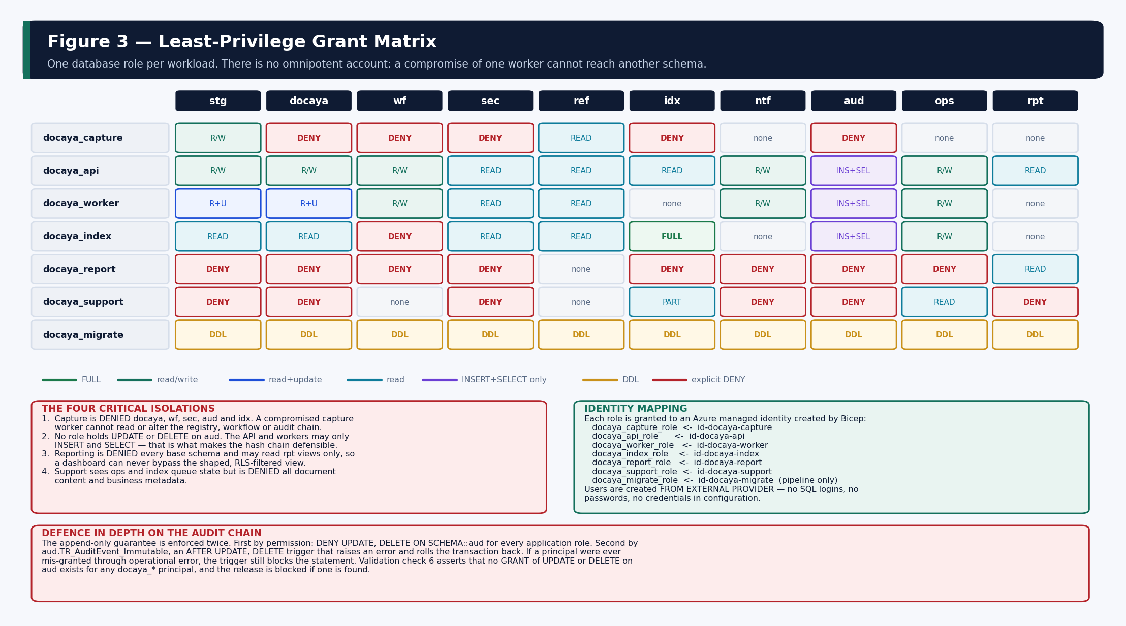
Figure 2 — The grant matrix as deployed. Seven roles, ten schemas, and the explicit denials that isolate each workload.

7.1 Confirm Role Membership
-- Every workload identity should appear against exactly one docaya_* role.
SELECT RoleName = r.name,
MemberName = m.name,
MemberType = m.type_desc
FROM sys.database_role_members rm
JOIN sys.database_principals r ON r.principal_id = rm.role_principal_id
JOIN sys.database_principals m ON m.principal_id = rm.member_principal_id
WHERE r.name LIKE 'docaya[_]%'
ORDER BY r.name;

7.2 Confirm the Critical Denials
-- Expect rows for capture (docaya, wf, sec, aud, idx) and report (all base schemas).
SELECT Principal = pr.name,
Schema_ = SCHEMA_NAME(p.major_id),
Permission = p.permission_name,
State = p.state_desc
FROM sys.database_permissions p
JOIN sys.database_principals pr ON pr.principal_id = p.grantee_principal_id
WHERE p.class_desc = 'SCHEMA'
AND p.state_desc = 'DENY'
AND pr.name LIKE 'docaya[_]%'
ORDER BY pr.name, SCHEMA_NAME(p.major_id);

7.3 Negative Tests
These prove the isolation is real rather than assumed. Run each impersonating the named role; every one must fail.
Test | Statement | Expected
Capture cannot read the registry | SELECT TOP 1 * FROM docaya.Document; | Permission denied on schema docaya
Capture cannot read the audit chain | SELECT TOP 1 * FROM aud.AuditEvent; | Permission denied on schema aud
API cannot update the audit chain | UPDATE aud.AuditEvent SET Outcome = 'Failed'; | Denied by DENY, then by trigger
API cannot delete a document | DELETE FROM docaya.Document; | Permission denied — disposition is a governed action
Reporting cannot read base tables | SELECT TOP 1 * FROM docaya.Document; | Permission denied on schema docaya
Support cannot read document content | SELECT TOP 1 * FROM docaya.Document; | Permission denied on schema docaya
Index worker cannot alter a document | UPDATE docaya.Document SET BusinessTitle = 'x'; | Permission denied on schema docaya

-- Pattern for running a negative test
EXECUTE AS USER = 'id-docaya-capture';
BEGIN TRY
SELECT TOP (1) * FROM docaya.Document;
SELECT Result = N'FAIL - access was permitted';
END TRY
BEGIN CATCH
SELECT Result = N'PASS - ' + ERROR_MESSAGE();
END CATCH
REVERT;

8. Operations

8.1 Scheduled Jobs
These run from the Docaya Functions workers, not from SQL Agent (which is unavailable in Azure SQL Database). Each writes an ops.JobRun row.
Job | Procedure | Cadence | Effect
SLA sweep | wf.usp_SweepSlaStatus | Hourly during working hours | Recomputes remaining working days; raises AtRisk and Overdue exactly once each.
Staging purge | docaya.usp_PurgeStagingArtifacts | Nightly | Deletes committed chunk receipts, expires abandoned sessions, marks published files reconciled.
Audit verification | aud.usp_VerifyChain @CreateCheckpoint = 1 | Nightly | Recomputes from the last checkpoint; a broken link is a security incident.
Index reconcile | (indexing worker · writes idx.IndexReconcile) | Nightly and on demand | Compares the SQL registry to the search index and repairs drift.

8.2 Monitoring Queries
Each of these is served by a filtered or covering index, so none scans a base table.
-- Promotion backlog and quarantine
SELECT ResultCode, Items = COUNT(*), OldestUtc = MIN(StartedUtc)
FROM ops.PromotionLedger
WHERE ResultCode IN (N'Pending', N'Quarantined', N'Failed')
GROUP BY ResultCode;

-- Outbox dispatch lag
SELECT Undispatched = COUNT(*), OldestUtc = MIN(CreatedUtc)
FROM ops.OutboxMessage WHERE DispatchedUtc IS NULL;

-- Index drift
SELECT HealthState, Records = COUNT(*) FROM rpt.vwIndexHealth GROUP BY HealthState;

-- Authorization denial spike (possible probing or misconfiguration)
SELECT PrincipalId, Denials = COUNT(*)
FROM sec.AccessDecisionLog
WHERE Decision = N'Deny' AND DecidedUtc >= DATEADD(HOUR, -1, SYSUTCDATETIME())
GROUP BY PrincipalId HAVING COUNT(*) > 20;

-- Dead-letter depth
SELECT Source, Items = COUNT(*), OldestUtc = MIN(EnqueuedUtc)
FROM ops.DeadLetter WHERE ReplayedUtc IS NULL GROUP BY Source;

8.3 Growth and Retention
Schema | Growth driver | Retention approach
stg | Upload volume; rows are short-lived by design. | Chunk receipts deleted on commit; staged files reconciled after publication.
docaya | Document count — one registry row plus one row per approved version. | Permanent; subject only to governed disposition under retention policy.
wf | Review activity — several stage and thread rows per document per revision. | Permanent while the document exists; a partitioning candidate at high volume.
sec.AccessDecisionLog | Every authorization evaluation — the highest-volume table. | Prunable on an agreed window; the durable record of a denial remains in aud.
idx | Approved versions multiplied by passage count. | Fully rebuildable; may be truncated and rebuilt at any time.
ntf | Recipients multiplied by events; broadcast publication is the largest contributor. | Prunable; ntf.BroadcastAudience is retained as delivery evidence.
aud | Every action by every actor. Append-only. | Exported to immutable storage for long-term retention; never deleted from the live chain.

8.4 Backup and Recovery Objectives
Store | Mechanism | RPO | RTO | Validation
Azure SQL | Point-in-time restore plus long-term retention; geo-redundant where required. | ≤ 5 minutes | ≤ 1 hour | Quarterly restore rehearsal with aud.usp_VerifyChain on the restored copy.
Derived schemas (idx, rpt) | None required — rebuilt from docaya plus SharePoint. | n/a | Rebuild window | Full rebuild timed and re-verified annually.
Configuration | Versioned in ops.ConfigurationSet and in the release package. | Per release | Immediate | Re-import from the release manifest.

9. Troubleshooting and Rollback

9.1 Common Deployment Failures
Symptom | Cause | Resolution
Script 01 prints SKIPPED for every identity | Not connected with an Entra identity, or the managed identities do not exist yet. | Confirm the session with the query in 3.3, then re-run script 01 alone after the Bicep identity module completes.
“Principal … could not be found” on CREATE USER | The managed identity name in the script does not match the one Bicep created. | Edit the @identities table at the top of script 01 to match the actual display names.
Foreign key creation fails in script 04 | Scripts were run out of order — ref or sec is missing. | Run 02 and 03 first. All scripts are idempotent, so re-running from 02 is safe.
Validation check 6 fails | A GRANT of UPDATE or DELETE on aud exists for a docaya_* principal. | Re-run script 13. Investigate how the grant was introduced — this is a security finding, not a deployment defect.
Validation check 7 fails | The capture role is not denied the docaya schema. | Re-run script 13 and confirm no later script or manual change removed the DENY.
Validation check 21 fails | ref.WorkingWeek is not seeded, or the calendar version does not match. | Re-run script 14. Confirm ref.WorkingWeek contains seven rows for UAE-FED version 1.
Reports return zero rows | Row-level security was enabled before SESSION_CONTEXT was populated. | Set the policy back to STATE = OFF, confirm the embed-token service, then re-enable.
Timeout on a large index creation | Under-provisioned service tier during initial deployment. | Scale up for the deployment window, then scale back. Scripts are idempotent and may be re-run.

9.2 Rollback
Scenario | Approach
Failed deployment mid-script | Scripts are idempotent. Correct the cause and re-run from the failing script; earlier scripts detect existing objects and skip.
Schema rollback to a prior version | Re-deploy the previous migration bundle from the release package using the migration identity.
Data recovery | Azure SQL point-in-time restore into an isolated database, then run aud.usp_VerifyChain to confirm the audit chain survived intact.
Derived data loss | Truncate idx.* and rebuild from docaya plus SharePoint; re-run the Power BI refresh. No backup restore is required.
Configuration rollback | ops.ConfigurationSet holds every published version; restoring a prior version is an atomic flag change, not an edit.
Full teardown (non-production only) | Drop the database and re-run the full script set. Never perform this against an environment holding live documents.

9.3 Health Check After Any Incident
-- 1) Re-run the full validation gate
-- (execute 15_validation_checks.sql)

-- 2) Verify the audit chain end to end
EXEC aud.usp_VerifyChain @FromAuditEventId = 0;

-- 3) Confirm no promotion is stuck
SELECT * FROM ops.PromotionLedger
WHERE ResultCode IN (N'Pending', N'Quarantined', N'Failed')
ORDER BY StartedUtc;

-- 4) Confirm the index matches the registry
SELECT HealthState, COUNT(*) FROM rpt.vwIndexHealth GROUP BY HealthState;

10. Pre-Production Checklist
The database is functional on first deployment, but two items must be closed before it is trusted with live documents, and several others require client confirmation.

10.1 Mandatory Before Go-Live
# | Item | Why it matters | Owner
1 | Load ref.HolidayCalendar with client-confirmed UAE public holidays. | Until this is done the SLA engine computes targets as if no public holidays exist, so 12- and 30-working-day commitments will be wrong. | Client HR / PMO (A4)
2 | Confirm the weekend pattern in ref.WorkingWeek. | Seeded as Saturday and Sunday non-working; confirm against actual client practice. | Client HR / PMO (A4)
3 | Confirm ref.DocumentClass, ref.Department and ref.Standard. | These drive SharePoint library resolution and folder paths; placeholder values will publish to the wrong location. | PMO / Records (A2)
4 | Confirm ref.RetentionPolicy schedules and disposition actions. | Placeholder policies must not govern real records. | Records & Compliance (A2)
5 | Confirm ref.SlaTarget values and the at-risk warning window. | Seeded at 12 / 30 working days with 3 / 5-day warnings. | PMO (A3)
6 | Confirm the review chain stage count and roles. | Seeded as a single global four-stage chain; departmental variants are added through the Admin Center. | PMO (A3)
7 | Decide on customer-managed keys and Always Encrypted. | TDE is on with platform-managed keys; CMK is available where client policy requires it. | Client Security (A9)
8 | Enable row-level security after the embed-token service is confirmed. | The policy ships OFF; enabling it prematurely makes every report return zero rows. | Architecture / Analytics

10.2 Sign-Off
Verification | Evidence | Signed off by
All 16 scripts executed without error | Deployment log retained with the release manifest
Validation script 15 passed all 22 assertions | Result set captured in the pipeline output
Role membership confirmed for all seven identities | Query output from Section 7.1
Negative access tests all failed as expected | Query output from Section 7.3
Holiday calendar loaded and arithmetic verified | Query output from Section 5.2
Smoke test passed including the immutability trigger | Query output from Section 6.3
Backup and restore rehearsal completed | Restore log plus aud.usp_VerifyChain result

Deployment complete Once every item in Section 10.1 is closed and the sign-off table in Section 10.2 is complete, the database is ready for the application to be pointed at it. Retain the deployment log, the validation output and the negative-test results with the release manifest as deployment evidence.

— End of Document —

